**PWM Signal Verification with the help of LED**

**using Fuzzy Logic Controller**

**Verilog Code:**

// Code your design here

`timescale 1ns / 1ps

//////////////////////////////////////////////////////////////////////////////////

// Company:

// Engineer:

//

// Create Date: 04/22/2024 06:30:56 PM

// Design Name:

// Module Name: TOP

// Project Name:

// Target Devices:

// Tool Versions:

// Description:

//

// Dependencies:

//

// Revision:

// Revision 0.01 - File Created

// Additional Comments:

//

//////////////////////////////////////////////////////////////////////////////////

// Code your design here

module TOP_LED(

input CLK_TOP,

input RESET_TOP,

input [7:0] BCD_TOP,

//output [7:0] digital_freq,

output [7:0] DUTY_TOP,

//output [7:0] fuzzy_set_id

output LED_TOP

);

// PWM Output Pin of LED of FPGA/SoC Developement Board

wire PWM_OUT_TOP;

wire [7:0] DIGITAL_FREQ_TOP;

// Digital Output Frequency

wire [7:0] OUT_DIG_FREQ_TOP;

//wire [7:0] output_fuzzy_set_id;

// Input FUZZY FREQUENCY

wire [7:0] PTR_FREQ_FUZZY_TOP;

wire [7:0] PTR_INPUT_FUZZY_SET_ID_TOP;

//Input FUZZY SETS

wire [7:0] PTR_negGIGANTIC_TOP;

wire [7:0] PTR_negHUGE_TOP;

wire [7:0] PTR_negBIG_TOP;

wire [7:0] PTR_negMEDIUM_TOP;

wire [7:0] PTR_negSMALL_TOP;

wire [7:0] PTR_ZERO_TOP;

wire [7:0] PTR_posSMALL_TOP;

wire [7:0] PTR_posMEDIUM_TOP;

wire [7:0] PTR_posBIG_TOP;

wire [7:0] PTR_posHUGE_TOP;

wire [7:0] PTR_posGIGANTIC_TOP;

wire [7:0] OUTPUT_FUZZY_SET_ID_TOP;

wire [7:0] PWM_DUTY_CYCLE_TOP;

//reg PROCESS_Control = 2'b00;

// 1. MODULE to Digitize the BCD Value That is Received From The ADC

DIGITIZATION DIGITIZATION(

.CLK(CLK_TOP),

.INPUT_BIT(BCD_TOP),

.FREQ(DIGITAL_FREQ_TOP),

.OUT_DIG_FREQ(OUT_DIG_FREQ_TOP)

);

// 2. MODULE to Fuzzify The Input Frequency

FUZZIFICATION FUZZIFICATION(

.CLK(CLK_TOP),

.FREQ_CRISP(OUT_DIG_FREQ_TOP),

.PTR_FREQ_FUZZY(PTR_FREQ_FUZZY_TOP),

.PTR_INPUT_FUZZY_SET_ID(PTR_INPUT_FUZZY_SET_ID_TOP),

.PTR_negGIGANTIC(PTR_negGIGANTIC_TOP),

.PTR_negHUGE(PTR_negHUGE_TOP),

.PTR_negBIG(PTR_negBIG_TOP),

.PTR_negMEDIUM(PTR_negMEDIUM_TOP),

.PTR_negSMALL(PTR_negSMALL_TOP),

.PTR_ZERO(PTR_ZERO_TOP),

.PTR_posSMALL(PTR_posSMALL_TOP),

.PTR_posMEDIUM(PTR_posMEDIUM_TOP),

.PTR_posBIG(PTR_posBIG_TOP),

.PTR_posHUGE(PTR_posHUGE_TOP),

.PTR_posGIGANTIC(PTR_posGIGANTIC_TOP)

);

// 3. RULEBASE MODULE to Infer The Output Membership Function Based On The Input Membership Function

RULEBASE RULEBASE(

.CLK(CLK_TOP),

.INPUT_FUZZY_SET_ID(PTR_INPUT_FUZZY_SET_ID_TOP),

.OUTPUT_FUZZY_SET_ID(OUTPUT_FUZZY_SET_ID_TOP)

);

// 4. DEFUZZIFICATION MODULE to Defuzzify The Fuzzy Values Into a Crisp Output

DEFUZZIFICATION DEFUZZIFICATION(

.CLK(CLK_TOP),

.OUTPUT_FUZZY_SET_ID(OUTPUT_FUZZY_SET_ID_TOP),

.PWM_DUTY(PWM_DUTY_CYCLE_TOP)

);

PWM_DUTY_MOD PWM_DUTY_MOD(.CLK(CLK_TOP),

.RESET(RESET_TOP),

.PWM_DUTY_ONE(PWM_DUTY_CYCLE_TOP),

.PWM_OUT(PWM_OUT_TOP)

);

assign DUTY_TOP = PWM_DUTY_CYCLE_TOP;

//assign fuzzy_set_id = output_fuzzy_set_id;

assign LED_TOP = PWM_OUT_TOP;

endmodule

// Digitization Module

module DIGITIZATION(

input CLK,

input [7:0] INPUT_BIT,

output [7:0] OUT_DIG_FREQ,

output [7:0] FREQ

);

reg BIT_ONE = 1'b1;

reg BIT_ZER = 1'b0;

reg [3:0] LSB_DIG;

reg [3:0] MSB_DIG;

reg [7:0] INTERNAL_FREQ;

// This 'always' Block Only Converts The Data Bits Received In The PMOD Ports of The FPGA BOARD to Binary Digit Values.

always @(posedge CLK)

begin

// Aassigning Appropriate Values to The BCD LSB

if ((INPUT_BIT[3] == BIT_ZER) && (INPUT_BIT[2] == BIT_ZER) && (INPUT_BIT[1] == BIT_ZER) && (INPUT_BIT[0] == BIT_ZER))

begin

LSB_DIG <= 4'b0000;

end

else if ((INPUT_BIT[3] == BIT_ZER) && (INPUT_BIT[2] == BIT_ZER) && (INPUT_BIT[1] == BIT_ZER) && (INPUT_BIT[0] == BIT_ONE))

begin

LSB_DIG <= 4'b0001;

end

else if ((INPUT_BIT[3] == BIT_ZER) && (INPUT_BIT[2] == BIT_ZER) && (INPUT_BIT[1] == BIT_ONE) && (INPUT_BIT[0] == BIT_ZER))

begin

LSB_DIG <= 4'b0010;

end

else if ((INPUT_BIT[3] == BIT_ZER) && (INPUT_BIT[2] == BIT_ZER) && (INPUT_BIT[1] == BIT_ONE) && (INPUT_BIT[0] == BIT_ONE))

begin

LSB_DIG <= 4'b0011;

end

else if ((INPUT_BIT[3] == BIT_ZER) && (INPUT_BIT[2] == BIT_ONE) && (INPUT_BIT[1] == BIT_ZER) && (INPUT_BIT[0] == BIT_ZER))

begin

LSB_DIG <= 4'b0100;

end

else if ((INPUT_BIT[3] == BIT_ZER) && (INPUT_BIT[2] == BIT_ONE) && (INPUT_BIT[1] == BIT_ZER) && (INPUT_BIT[0] == BIT_ONE))

begin

LSB_DIG <= 4'b0101;

end

else if ((INPUT_BIT[3] == BIT_ZER) && (INPUT_BIT[2] == BIT_ONE) && (INPUT_BIT[1] == BIT_ONE) && (INPUT_BIT[0] == BIT_ZER))

begin

LSB_DIG <= 4'b0110;

end

else if ((INPUT_BIT[3] == BIT_ZER) && (INPUT_BIT[2] == BIT_ONE) && (INPUT_BIT[1] == BIT_ONE) && (INPUT_BIT[0] == BIT_ONE))

begin

LSB_DIG <= 4'b0111;

end

else if ((INPUT_BIT[3] == BIT_ONE) && (INPUT_BIT[2] == BIT_ZER) && (INPUT_BIT[1] == BIT_ZER) && (INPUT_BIT[0] == BIT_ZER))

begin

LSB_DIG <= 4'b1000;

end

else if ((INPUT_BIT[3] == BIT_ONE) && (INPUT_BIT[2] == BIT_ZER) && (INPUT_BIT[1] == BIT_ZER) && (INPUT_BIT[0] == BIT_ONE))

begin

LSB_DIG <= 4'b1001;

end

// Aassigning Appropriate Values to The BCD MSB

if ((INPUT_BIT[7] == BIT_ZER) && (INPUT_BIT[6] == BIT_ZER) && (INPUT_BIT[5] == BIT_ZER) && (INPUT_BIT[4] == BIT_ZER))

begin

MSB_DIG <= 4'b0000;

end

else if ((INPUT_BIT[7] == BIT_ZER) && (INPUT_BIT[6] == BIT_ZER) && (INPUT_BIT[5] == BIT_ZER) && (INPUT_BIT[4] == BIT_ONE))

begin

MSB_DIG <= 4'b0001;

end

else if ((INPUT_BIT[7] == BIT_ZER) && (INPUT_BIT[6] == BIT_ZER) && (INPUT_BIT[5] == BIT_ONE) && (INPUT_BIT[4] == BIT_ZER))

begin

MSB_DIG <= 4'b0010;

end

else if ((INPUT_BIT[7] == BIT_ZER) && (INPUT_BIT[6] == BIT_ZER) && (INPUT_BIT[5] == BIT_ONE) && (INPUT_BIT[4] == BIT_ONE))

begin

MSB_DIG <= 4'b0011;

end

else if ((INPUT_BIT[7] == BIT_ZER) && (INPUT_BIT[6] == BIT_ONE) && (INPUT_BIT[5] == BIT_ZER) && (INPUT_BIT[4] == BIT_ZER))

begin

MSB_DIG <= 4'b0100;

end

else if ((INPUT_BIT[7] == BIT_ZER) && (INPUT_BIT[6] == BIT_ONE) && (INPUT_BIT[5] == BIT_ZER) && (INPUT_BIT[4] == BIT_ONE))

begin

MSB_DIG <= 4'b0101;

end

else if ((INPUT_BIT[7] == BIT_ZER) && (INPUT_BIT[6] == BIT_ONE) && (INPUT_BIT[5] == BIT_ONE) && (INPUT_BIT[4] == BIT_ZER))

begin

MSB_DIG <= 4'b0110;

end

else if ((INPUT_BIT[7] == BIT_ZER) && (INPUT_BIT[6] == BIT_ONE) && (INPUT_BIT[5] == BIT_ONE) && (INPUT_BIT[4] == BIT_ONE))

begin

MSB_DIG <= 4'b0111;

end

else if ((INPUT_BIT[7] == BIT_ONE) && (INPUT_BIT[6] == BIT_ZER) && (INPUT_BIT[5] == BIT_ZER) && (INPUT_BIT[4] == BIT_ZER))

begin

MSB_DIG <= 4'b1000;

end

else if ((INPUT_BIT[7] == BIT_ONE) && (INPUT_BIT[6] == BIT_ZER) && (INPUT_BIT[5] == BIT_ZER) && (INPUT_BIT[4] == BIT_ONE))

begin

MSB_DIG <= 4'b1001;

end

end

always @*

begin

INTERNAL_FREQ <= (MSB_DIG * 4'b1010) + {3'b0, LSB_DIG};

end

assign FREQ = INTERNAL_FREQ;

reg [7:0] DIG_FREQ;

parameter ZER = 5'b00000;

parameter ONE = 5'b00001;

parameter TWO = 5'b00010;

parameter THR = 5'b00011;

parameter FOR = 5'b00100;

parameter FIV = 5'b00101;

parameter SIX = 5'b00110;

parameter SEV = 5'b00111;

parameter EIG = 5'b01000;

parameter NIN = 5'b01001;

parameter TEN = 5'b01010;

parameter ELE = 5'b01011;

parameter TWE = 5'b01100;

parameter THI = 5'b01101;

parameter FRT = 5'b01110;

parameter FIF = 5'b01111;

parameter SXT = 5'b10000;

parameter SVT = 5'b10001;

parameter EIT = 5'b10010;

parameter NIT = 5'b10011;

parameter TWT = 5'b10100;

parameter TON = 5'b10101;

parameter FORTY_eBIT = 8'b00101000;

parameter FORTY_ONE_eBIT = 8'b00101001;

parameter FORTY_TWO_eBIT = 8'b00101010;

parameter FORTY_THREE_eBIT = 8'b00101011;

parameter FORTY_FOUR_eBIT = 8'b00101100;

parameter FORTY_FIVE_eBIT = 8'b00101101;

parameter FORTY_SIX_eBIT = 8'b00101110;

parameter FORTY_SEVEN_eBIT = 8'b00101111;

parameter FORTY_EIGHT_eBIT = 8'b00110000;

parameter FORTY_NINE_eBIT = 8'b00110001;

parameter FIFTY_eBIT = 8'b00110010;

parameter FIFTY_ONE_eBIT = 8'b00110011;

parameter FIFTY_TWO_eBIT = 8'b00110100;

parameter FIFTY_THREE_eBIT = 8'b00110101;

parameter FIFTY_FOUR_eBIT = 8'b00110110;

parameter FIFTY_FIVE_eBIT = 8'b00110111;

parameter FIFTY_SIX_eBIT = 8'b00111000;

parameter FIFTY_SEVEN_eBIT = 8'b00111001;

parameter FIFTY_EIGHT_eBIT = 8'b00111010;

parameter FIFTY_NINE_eBIT = 8'b00111011;

parameter SIXTY_eBIT = 8'b00111100;

always @(posedge CLK)

begin

if(INTERNAL_FREQ <= FORTY_eBIT)

begin

DIG_FREQ = ZER;

end

else if((INTERNAL_FREQ > FORTY_eBIT) && (INTERNAL_FREQ <= FORTY_ONE_eBIT))

begin

DIG_FREQ = ONE;

end

else if((INTERNAL_FREQ > FORTY_ONE_eBIT ) && (INTERNAL_FREQ <= FORTY_TWO_eBIT))

begin

DIG_FREQ = TWO;

end

else if((INTERNAL_FREQ > FORTY_TWO_eBIT) && (INTERNAL_FREQ <= FORTY_THREE_eBIT))

begin

DIG_FREQ = THR;

end

else if((INTERNAL_FREQ > FORTY_THREE_eBIT) && (INTERNAL_FREQ <= FORTY_FOUR_eBIT))

begin

DIG_FREQ = FOR;

end

else if((INTERNAL_FREQ > FORTY_FOUR_eBIT) && (INTERNAL_FREQ <= FORTY_FIVE_eBIT))

begin

DIG_FREQ = FIV;

end

else if((INTERNAL_FREQ > FORTY_FIVE_eBIT) && (INTERNAL_FREQ<= FORTY_SIX_eBIT))

begin

DIG_FREQ = SIX;

end

else if((INTERNAL_FREQ > FORTY_SIX_eBIT) && (INTERNAL_FREQ <= FORTY_SEVEN_eBIT))

begin

DIG_FREQ = SEV;

end

else if((INTERNAL_FREQ > FORTY_SEVEN_eBIT) && (INTERNAL_FREQ <= FORTY_EIGHT_eBIT))

begin

DIG_FREQ = EIG;

end

else if((INTERNAL_FREQ > FORTY_EIGHT_eBIT) && (INTERNAL_FREQ <= FORTY_NINE_eBIT))

begin

DIG_FREQ = NIN;

end

else if((INTERNAL_FREQ > FORTY_NINE_eBIT) && (INTERNAL_FREQ <= FIFTY_eBIT))

begin

DIG_FREQ = TEN;

end

else if((INTERNAL_FREQ > FIFTY_eBIT) && (INTERNAL_FREQ <= FIFTY_ONE_eBIT))

begin

DIG_FREQ = ELE;

end

else if((INTERNAL_FREQ > FIFTY_ONE_eBIT) && (INTERNAL_FREQ <= FIFTY_TWO_eBIT))

begin

DIG_FREQ = TWE;

end

else if((INTERNAL_FREQ > FIFTY_TWO_eBIT) && (INTERNAL_FREQ <= FIFTY_THREE_eBIT))

begin

DIG_FREQ = THI;

end

else if((INTERNAL_FREQ > FIFTY_THREE_eBIT) && (INTERNAL_FREQ <= FIFTY_FOUR_eBIT))

begin

DIG_FREQ = FRT;

end

else if((INTERNAL_FREQ > FIFTY_FOUR_eBIT) && (INTERNAL_FREQ <= FIFTY_FIVE_eBIT))

begin

DIG_FREQ = FIF;

end

else if((INTERNAL_FREQ > FIFTY_FIVE_eBIT) && (INTERNAL_FREQ <= FIFTY_SIX_eBIT))

begin

DIG_FREQ = SXT;

end

else if((INTERNAL_FREQ > FIFTY_SIX_eBIT) && (INTERNAL_FREQ <= FIFTY_SEVEN_eBIT))

begin

DIG_FREQ = SVT;

end

else if((INTERNAL_FREQ > FIFTY_SEVEN_eBIT) && (INTERNAL_FREQ <= FIFTY_EIGHT_eBIT))

begin

DIG_FREQ = EIT;

end

else if((INTERNAL_FREQ > FIFTY_EIGHT_eBIT) && (INTERNAL_FREQ <= FIFTY_NINE_eBIT))

begin

DIG_FREQ = NIT;

end

else if((INTERNAL_FREQ > FIFTY_NINE_eBIT) && (INTERNAL_FREQ <= SIXTY_eBIT))

begin

DIG_FREQ = TWT;

end

else if(INTERNAL_FREQ > SIXTY_eBIT)

begin

DIG_FREQ = TON;

end

end

assign OUT_DIG_FREQ = DIG_FREQ;

endmodule

// Fuzzification

module FUZZIFICATION (

input CLK,

input [7:0] FREQ_CRISP,

output [7:0] PTR_FREQ_FUZZY,

output [7:0] PTR_INPUT_FUZZY_SET_ID,

output [7:0] PTR_negGIGANTIC,

output [7:0] PTR_negHUGE,

output [7:0] PTR_negBIG,

output [7:0] PTR_negMEDIUM,

output [7:0] PTR_negSMALL,

output [7:0] PTR_ZERO,

output [7:0] PTR_posSMALL,

output [7:0] PTR_posMEDIUM,

output [7:0] PTR_posBIG,

output [7:0] PTR_posHUGE,

output [7:0] PTR_posGIGANTIC

);

reg [7:0] INT_FREQ_FUZZY;

reg [7:0] INT_INPUT_FUZZY_SET_ID;

reg [7:0] INT_negGIGANTIC;

reg [7:0] INT_negHUGE;

reg [7:0] INT_negBIG;

reg [7:0] INT_negMEDIUM;

reg [7:0] INT_negSMALL;

reg [7:0] INT_ZERO;

reg [7:0] INT_posSMALL;

reg [7:0] INT_posMEDIUM;

reg [7:0] INT_posBIG;

reg [7:0] INT_posHUGE;

reg [7:0] INT_posGIGANTIC;

parameter ZERO_eBIT = 8'b00000000;

parameter ONE_eBIT = 8'b00000001;

parameter TWO_eBIT = 8'b00000010;

parameter THREE_eBIT = 8'b00000011;

parameter FOUR_eBIT = 8'b00000100;

parameter FIVE_eBIT = 8'b00000101;

parameter SIX_eBIT = 8'b00000110;

parameter SEVEN_eBIT = 8'b00000111;

parameter EIGHT_eBIT = 8'b00001000;

parameter NINE_eBIT = 8'b00001001;

parameter TEN_eBIT = 8'b00001010;

parameter ELEVEN_eBIT = 8'b00001011;

parameter TWELVE_eBIT = 8'b00001100;

parameter THIRTEEN_eBIT = 8'b00001101;

parameter FOURTEEN_eBIT = 8'b00001110;

parameter FIFTEEN_eBIT = 8'b00001111;

parameter SIXTEEN_eBIT = 8'b00010000;

parameter SEVENTEEN_eBIT = 8'b00010001;

parameter EIGHTEEN_eBIT = 8'b00010010;

parameter NINETEEN_eBIT = 8'b00010011;

parameter TWENTY_eBIT = 8'b00010100;

// Internal Register to Hold The Crisp Value of Frequency

reg [7:0] INT_FREQ_CRISP;

always@ (posedge CLK)

begin

INT_FREQ_CRISP <= FREQ_CRISP;

if (INT_FREQ_CRISP < ZERO_eBIT)

begin

INT_negGIGANTIC <= ONE_eBIT; // Neg Gignatic

// Identifying The Selected Fuzzy Set

INT_INPUT_FUZZY_SET_ID <= ONE_eBIT;

// The Input to Rule Base is Calculated With MAX Rule, Direct Assignment Works As Only One Value Exists

INT_FREQ_FUZZY <= INT_negGIGANTIC;

/* Set everything else to zero */

INT_negHUGE <= 8'b00000000;

INT_negBIG <= 8'b00000000;

INT_negMEDIUM <= 8'b00000000;

INT_negSMALL <= 8'b00000000;

INT_ZERO <= 8'b00000000;

INT_posSMALL <= 8'b00000000;

INT_posMEDIUM <= 8'b00000000;

INT_posBIG <= 8'b00000000;

INT_posHUGE <= 8'b00000000;

INT_posGIGANTIC <= 8'b00000000;

end

else if ((INT_FREQ_CRISP >= ZERO_eBIT) && (INT_FREQ_CRISP < TWO_eBIT))

begin

// Int_negHuge <= FREQ_CRISP

// int_negGigantic <= (TWO_eBIT - int_freq_crisp)

// Instead of a Division Algo, a Division by 2 LUT is created below.

case (FREQ_CRISP)

ZERO_eBIT:

begin

INT_negHUGE <= ZERO_eBIT; // 0 / 2 = 0

INT_negGIGANTIC <= ONE_eBIT; // (2-0) / 2 = 1

end

ONE_eBIT:

begin

INT_negHUGE <= ONE_eBIT; // 1 / 2 = 1

INT_negGIGANTIC <= ZERO_eBIT; // (2-1) / 2 = 1

end

endcase

if (INT_negHUGE >= INT_negGIGANTIC)

begin

INT_FREQ_FUZZY <= INT_negHUGE;

INT_INPUT_FUZZY_SET_ID <= TWO_eBIT;

end

else

begin

INT_FREQ_FUZZY <= INT_negGIGANTIC;

INT_INPUT_FUZZY_SET_ID <= ONE_eBIT;

end

// Set Everything Else to Zero

INT_negBIG <= 8'b00000000;

INT_negMEDIUM <= 8'b00000000;

INT_negSMALL <= 8'b00000000;

INT_ZERO <= 8'b00000000;

INT_posSMALL <= 8'b00000000;

INT_posMEDIUM <= 8'b00000000;

INT_posBIG <= 8'b00000000;

INT_posHUGE <= 8'b00000000;

INT_posGIGANTIC <= 8'b00000000;

end

else if ((INT_FREQ_CRISP >= TWO_eBIT) && (INT_FREQ_CRISP < FOUR_eBIT))

begin

case (FREQ_CRISP)

TWO_eBIT:

begin

// int_negHuge <= (four_ebit - int_freq_crisp) / two_ebit;

INT_negHUGE <= ONE_eBIT; /* (4 - 2) / 2 = 1 */

// int_negBig <= (int_freq_crisp - two_ebit) / two_ebit;

INT_negBIG <= ZERO_eBIT; /* (2 - 2) / 2 = 0 */

end

THREE_eBIT:

begin

// int_negHuge <= (four_ebit - int_freq_crisp) / two_ebit ;

INT_negHUGE <= ZERO_eBIT; /* (4 - 3) / 2 = 1 */

// int_negBig <= (int_freq_crisp - two_ebit) / two_ebit ;

INT_negBIG <= ONE_eBIT; /* (3 - 2) / 2 = 0 */

end

endcase

if (INT_negHUGE >= INT_negBIG)

begin

INT_FREQ_FUZZY <= INT_negHUGE;

INT_INPUT_FUZZY_SET_ID <= TWO_eBIT;

end

else

begin

INT_FREQ_FUZZY <= INT_negBIG;

INT_INPUT_FUZZY_SET_ID <= THREE_eBIT;

end

// Set Everything Else to Zero

INT_negGIGANTIC <= 8'b00000000;

INT_negMEDIUM <= 8'b00000000;

INT_negSMALL <= 8'b00000000;

INT_ZERO <= 8'b00000000;

INT_posSMALL <= 8'b00000000;

INT_posMEDIUM <= 8'b00000000;

INT_posBIG <= 8'b00000000;

INT_posHUGE <= 8'b00000000;

INT_posGIGANTIC <= 8'b00000000;

end

else if ((INT_FREQ_CRISP >= FOUR_eBIT) && (INT_FREQ_CRISP < SIX_eBIT))

begin

case (FREQ_CRISP)

FOUR_eBIT:

begin

// int_negBig <= (six_ebit - int_freq_crisp) / two_ebit;

INT_negBIG <= ONE_eBIT; // (6 - 4) / 2 = 1 (44 Hz Should be Negative Big With 1 Membership Value)

// int_negMedium <= (int_freq_crisp - 4) / two_ebit; */

INT_negMEDIUM <= ZERO_eBIT; // (4 - 2) / 2 = 1 (44 Hz Should be Negative Medium with 0 Membership Value)

end

FIVE_eBIT:

begin

// int_negBig <= (six_ebit - int_freq_crisp) / two_ebit;

INT_negBIG <= ZERO_eBIT; // (6 - 5) / 2 = 0.5 (45 Hz should be negative Big with 0 membership value)

// int_negMedium <= (int_freq_crisp - 4) / two_ebit;

INT_negMEDIUM <= ONE_eBIT; // (5 - 4) / 2 = 0.5 (44 Hz should be negative medium with 1 membership value)

end

endcase

// Selecting the Maximum Value

if (INT_negBIG >= INT_negMEDIUM)

begin

INT_FREQ_FUZZY <= INT_negBIG;

INT_INPUT_FUZZY_SET_ID <= THREE_eBIT;

end

else

begin

INT_FREQ_FUZZY <= INT_negMEDIUM;

INT_INPUT_FUZZY_SET_ID <= FOUR_eBIT;

end

// Set Everything Else to Zero

INT_negGIGANTIC <= 8'b00000000;

INT_negHUGE <= 8'b00000000;

INT_negSMALL <= 8'b00000000;

INT_ZERO <= 8'b00000000;

INT_posSMALL <= 8'b00000000;

INT_posMEDIUM <= 8'b00000000;

INT_posBIG <= 8'b00000000;

INT_posHUGE <= 8'b00000000;

INT_posGIGANTIC <= 8'b00000000;

end

else if ((INT_FREQ_CRISP >= SIX_eBIT) && (INT_FREQ_CRISP < EIGHT_eBIT))

begin

case (FREQ_CRISP)

SIX_eBIT:

begin

INT_negMEDIUM <= ONE_eBIT;

INT_negSMALL <= ZERO_eBIT;

end

SEVEN_eBIT:

begin

INT_negMEDIUM <= ZERO_eBIT;

INT_negSMALL <= ONE_eBIT;

end

endcase

// Selecting the maximum value

if (INT_negMEDIUM >= INT_negSMALL)

begin

INT_FREQ_FUZZY <= INT_negMEDIUM;

INT_INPUT_FUZZY_SET_ID <= FOUR_eBIT;

end

else

begin

INT_FREQ_FUZZY <= INT_negSMALL;

INT_INPUT_FUZZY_SET_ID <= FIVE_eBIT;

end

// Set Everything Else to Zero

INT_negGIGANTIC <= 8'b00000000;

INT_negHUGE <= 8'b00000000;

INT_negBIG <= 8'b00000000;

INT_ZERO <= 8'b00000000;

INT_posSMALL <= 8'b00000000;

INT_posMEDIUM <= 8'b00000000;

INT_posBIG <= 8'b00000000;

INT_posHUGE <= 8'b00000000;

INT_posGIGANTIC <= 8'b00000000;

end

else if ((INT_FREQ_CRISP >= EIGHT_eBIT) && (INT_FREQ_CRISP < TWELVE_eBIT))

begin

case (FREQ_CRISP)

EIGHT_eBIT:

begin

INT_negSMALL <= ONE_eBIT;

INT_ZERO <= ZERO_eBIT;

end

NINE_eBIT:

begin

INT_negSMALL <= ZERO_eBIT;

INT_ZERO <= ONE_eBIT;

end

TEN_eBIT:

begin

INT_negSMALL <= ZERO_eBIT;

INT_ZERO <= ONE_eBIT;

end

ELEVEN_eBIT:

begin

INT_negSMALL <= ZERO_eBIT;

INT_ZERO <= ONE_eBIT;

end

endcase

// Selecting The Maximum Value

if (INT_negSMALL >= INT_ZERO)

begin

INT_FREQ_FUZZY <= INT_negSMALL;

INT_INPUT_FUZZY_SET_ID <= FIVE_eBIT;

end

else

begin

INT_FREQ_FUZZY <= INT_ZERO;

INT_INPUT_FUZZY_SET_ID <= SIX_eBIT;

end

// Set Everything Else to Zero

INT_negGIGANTIC <= 8'b00000000;

INT_negHUGE <= 8'b00000000;

INT_negBIG <= 8'b00000000;

INT_negMEDIUM <= 8'b00000000;

INT_posSMALL <= 8'b00000000;

INT_posMEDIUM <= 8'b00000000;

INT_posBIG <= 8'b00000000;

INT_posHUGE <= 8'b00000000;

INT_posGIGANTIC <= 8'b00000000;

end

else if ((INT_FREQ_CRISP >= TWELVE_eBIT) && (INT_FREQ_CRISP < FOURTEEN_eBIT))

begin

case (FREQ_CRISP)

TWELVE_eBIT:

begin

INT_ZERO <= ONE_eBIT;

INT_posSMALL <= ZERO_eBIT;

end

THIRTEEN_eBIT:

begin

INT_ZERO <= ZERO_eBIT;

INT_posSMALL <= ONE_eBIT;

end

endcase

// Selecting The Maximum Value

if (INT_ZERO >= INT_posSMALL)

begin

INT_FREQ_CRISP <= INT_ZERO;

INT_INPUT_FUZZY_SET_ID <= SIX_eBIT;

end

else

begin

INT_FREQ_FUZZY <= INT_posSMALL;

INT_INPUT_FUZZY_SET_ID <= SEVEN_eBIT;

end

// Set Everything Else to Zero

INT_negGIGANTIC <= 8'b00000000;

INT_negHUGE <= 8'b00000000;

INT_negBIG <= 8'b00000000;

INT_negMEDIUM <= 8'b00000000;

INT_negSMALL <= 8'b00000000;

INT_posMEDIUM <= 8'b00000000;

INT_posBIG <= 8'b00000000;

INT_posHUGE <= 8'b00000000;

INT_posGIGANTIC <= 8'b00000000;

end

else if ((INT_FREQ_CRISP >= FOURTEEN_eBIT) && (INT_FREQ_CRISP < SIXTEEN_eBIT))

begin

case(FREQ_CRISP)

FOURTEEN_eBIT:

begin

INT_posSMALL <= ONE_eBIT;

INT_posMEDIUM <= ZERO_eBIT;

end

FIFTEEN_eBIT:

begin

INT_posSMALL <= ZERO_eBIT;

INT_posMEDIUM <= ONE_eBIT;

end

endcase

if(INT_posMEDIUM >= INT_posSMALL)

begin

INT_FREQ_FUZZY <= INT_posMEDIUM;

INT_INPUT_FUZZY_SET_ID <= EIGHT_eBIT;

end

else

begin

INT_FREQ_FUZZY <= INT_posSMALL;

INT_INPUT_FUZZY_SET_ID <= SEVEN_eBIT;

end

// Set Everything Else to Zero

INT_negGIGANTIC <= 8'b00000000;

INT_negHUGE <= 8'b00000000;

INT_negBIG <= 8'b00000000;

INT_negMEDIUM <= 8'b00000000;

INT_negSMALL <= 8'b00000000;

INT_ZERO <= 8'b00000000;

INT_posBIG <= 8'b00000000;

INT_posHUGE <= 8'b00000000;

INT_posGIGANTIC <= 8'b00000000;

end

else if ((INT_FREQ_CRISP >= SIXTEEN_eBIT) && (INT_FREQ_CRISP < EIGHTEEN_eBIT))

begin

case (FREQ_CRISP)

SIXTEEN_eBIT:

begin

INT_posMEDIUM <= ONE_eBIT;

INT_posBIG <= ZERO_eBIT;

end

SEVENTEEN_eBIT:

begin

INT_posMEDIUM <= ZERO_eBIT;

INT_posBIG <= ONE_eBIT;

end

endcase

// Selecting The Maximum Value

if (INT_posBIG >= INT_posMEDIUM)

begin

INT_FREQ_FUZZY <= INT_posBIG;

INT_INPUT_FUZZY_SET_ID <= NINE_eBIT;

end

else

begin

INT_FREQ_FUZZY <= INT_posMEDIUM;

INT_INPUT_FUZZY_SET_ID <= EIGHT_eBIT;

end

// Set Everything Else to Zero

INT_negGIGANTIC <= 8'b00000000;

INT_negHUGE <= 8'b00000000;

INT_negBIG <= 8'b00000000;

INT_negMEDIUM <= 8'b00000000;

INT_negSMALL <= 8'b00000000;

INT_ZERO <= 8'b00000000;

INT_posSMALL <= 8'b00000000;

INT_posHUGE <= 8'b00000000;

INT_posGIGANTIC <= 8'b00000000;

end

else if ((INT_FREQ_CRISP >= EIGHTEEN_eBIT) && (INT_FREQ_CRISP <= TWENTY_eBIT))

begin

case (FREQ_CRISP)

EIGHTEEN_eBIT:

begin

INT_posBIG <= ONE_eBIT;

INT_posHUGE <= ZERO_eBIT;

end

NINETEEN_eBIT:

begin

INT_posBIG <= ZERO_eBIT;

INT_posHUGE <= ONE_eBIT;

end

endcase

// Selecting The Maximum Value

if (INT_posBIG >= INT_posHUGE)

begin

INT_FREQ_FUZZY <= INT_posBIG;

INT_INPUT_FUZZY_SET_ID <= NINE_eBIT;

end

else

begin

INT_FREQ_FUZZY <= INT_posHUGE;

INT_INPUT_FUZZY_SET_ID <= TEN_eBIT;

end

// Set Everything Else to Zero

INT_negGIGANTIC <= 8'b00000000;

INT_negHUGE <= 8'b00000000;

INT_negBIG <= 8'b00000000;

INT_negMEDIUM <= 8'b00000000;

INT_negSMALL <= 8'b00000000;

INT_ZERO <= 8'b00000000;

INT_posSMALL <= 8'b00000000;

INT_posMEDIUM <= 8'b00000000;

INT_posGIGANTIC <= 8'b00000000;

end

else if (INT_FREQ_CRISP >= TWENTY_eBIT)

begin

case (FREQ_CRISP)

TWENTY_eBIT:

begin

INT_posGIGANTIC <= ONE_eBIT;

end

endcase

// Selecting The Maximum Value

INT_FREQ_FUZZY <= INT_posGIGANTIC;

INT_INPUT_FUZZY_SET_ID <= ELEVEN_eBIT;

// Set Everything Else to Zero

INT_negGIGANTIC <= 8'b00000000;

INT_negHUGE <= 8'b00000000;

INT_negBIG <= 8'b00000000;

INT_negMEDIUM <= 8'b00000000;

INT_negSMALL <= 8'b00000000;

INT_ZERO <= 8'b00000000;

INT_posSMALL <= 8'b00000000;

INT_posMEDIUM <= 8'b00000000;

INT_posBIG <= 8'b00000000;

INT_posHUGE <= 8'b00000000;

end

end

assign PTR_FREQ_FUZZY = INT_FREQ_FUZZY;

assign PTR_INPUT_FUZZY_SET_ID = INT_INPUT_FUZZY_SET_ID;

assign PTR_negGIGANTIC = INT_negGIGANTIC;

assign PTR_negHUGE = INT_negHUGE;

assign PTR_negBIG = INT_negBIG;

assign PTR_negMEDIUM = INT_negMEDIUM;

assign PTR_negSMALL = INT_negSMALL;

assign PTR_ZERO = INT_ZERO;

assign PTR_posSMALL = INT_posSMALL;

assign PTR_posMEDIUM = INT_posMEDIUM;

assign PTR_posBIG = INT_posBIG;

assign PTR_posHUGE = INT_posHUGE;

assign PTR_posGIGANTIC = INT_posGIGANTIC;

endmodule

//RuleBase Mdoule

module RULEBASE(

input CLK,

input [7:0] INPUT_FUZZY_SET_ID,

output [7:0] OUTPUT_FUZZY_SET_ID

);

// Local Parameters to Represent The Numbers For Readability

localparam ONE_eBIT = 8'b00000001;

localparam TWO_eBIT = 8'b00000010;

localparam THREE_eBIT = 8'b00000011;

localparam FOUR_eBIT = 8'b00000100;

localparam FIVE_eBIT = 8'b00000101;

localparam SIX_eBIT = 8'b00000110;

localparam SEVEN_eBIT = 8'b00000111;

localparam EIGHT_eBIT = 8'b00001000;

localparam NINE_eBIT = 8'b00001001;

localparam TEN_eBIT = 8'b00001010;

localparam ELEVEN_eBIT = 8'b00001011;

// Internal Registers to Handle the Input and Ouput Fuzzy Sets IDs

reg [7:0] INT_INPUT_ID;

reg [7:0] INT_OUTPUT_ID;

always@ (posedge CLK)

begin

INT_INPUT_ID = INPUT_FUZZY_SET_ID;

if (INT_INPUT_ID == ONE_eBIT)

begin

INT_OUTPUT_ID = ELEVEN_eBIT;

end

else if (INT_INPUT_ID == TWO_eBIT)

begin

INT_OUTPUT_ID = TEN_eBIT;

end

else if (INT_INPUT_ID == THREE_eBIT)

begin

INT_OUTPUT_ID = NINE_eBIT;

end

else if (INT_INPUT_ID == FOUR_eBIT)

begin

INT_OUTPUT_ID = EIGHT_eBIT;

end

else if (INT_INPUT_ID == FIVE_eBIT)

begin

INT_OUTPUT_ID = SEVEN_eBIT;

end

else if (INT_INPUT_ID == SIX_eBIT)

begin

INT_OUTPUT_ID = SIX_eBIT;

end

else if (INT_INPUT_ID == SEVEN_eBIT)

begin

INT_OUTPUT_ID = FIVE_eBIT;

end

else if (INT_INPUT_ID == EIGHT_eBIT)

begin

INT_OUTPUT_ID = FOUR_eBIT;

end

else if (INT_INPUT_ID == NINE_eBIT)

begin

INT_OUTPUT_ID = THREE_eBIT;

end

else if (INT_INPUT_ID == TEN_eBIT)

begin

INT_OUTPUT_ID = TWO_eBIT;

end

else if (INT_INPUT_ID == ELEVEN_eBIT)

begin

INT_OUTPUT_ID = ONE_eBIT;

end

end

// Assigning The Value of The Internal Register to The Output

assign OUTPUT_FUZZY_SET_ID = INT_OUTPUT_ID;

endmodule

// Defuzzification

module DEFUZZIFICATION(

input CLK,

input [7:0] OUTPUT_FUZZY_SET_ID,

output [7:0] PWM_DUTY

);

// Local Parameters to Represent The Numbers for Readability

parameter LEN_FOUR = 3;

parameter LEN_EIGHT = 7;

parameter ZERO_eBIT = 8'b00000000;

parameter ONE_eBIT = 8'b00000001;

parameter TWO_eBIT = 8'b00000010;

parameter THREE_eBIT = 8'b00000011;

parameter FOUR_eBIT = 8'b00000100;

parameter FIVE_eBIT = 8'b00000101;

parameter SIX_eBIT = 8'b00000110;

parameter SEVEN_eBIT = 8'b00000111;

parameter EIGHT_eBIT = 8'b00001000;

parameter NINE_eBIT = 8'b00001001;

parameter TEN_eBIT = 8'b00001010;

parameter ELEVEN_eBIT = 8'b00001011;

parameter TWENTY_eBIT = 8'b00010100;

parameter THIRTY_eBIT = 8'b00011110;

parameter FOURTY_eBIT = 8'b00101000;

parameter FIFTY_eBIT = 8'b00110010;

parameter SIXTY_eBIT = 8'b00111100;

parameter SEVENTY_eBIT = 8'b01000110;

parameter EIGHTY_eBIT = 8'b01010000;

parameter NINETY_eBIT = 8'b01011010;

parameter HUNDRED_eBIT = 8'b01100100;

reg [LEN_EIGHT:0] MEMO_negGIGANTIC;

reg [LEN_EIGHT:0] MEMO_negHUGE;

reg [LEN_EIGHT:0] MEMO_negBIG;

reg [LEN_EIGHT:0] MEMO_negMEDIUM;

reg [LEN_EIGHT:0] MEMO_negSMALL;

reg [LEN_EIGHT:0] MEMO_ZERO;

reg [LEN_EIGHT:0] MEMO_posSMALL;

reg [LEN_EIGHT:0] MEMO_posMEDIUM;

reg [LEN_EIGHT:0] MEMO_posBIG;

reg [LEN_EIGHT:0] MEMO_posHUGE;

reg [LEN_EIGHT:0] MEMO_posGIGANTIC;

reg [7:0] DEGREE_MEM;

reg [7:0] DUTY_CYCLE;

always@ (posedge CLK)

begin

DEGREE_MEM = OUTPUT_FUZZY_SET_ID;

case (OUTPUT_FUZZY_SET_ID)

ONE_eBIT:

begin

// Division by 10 Causes a Floating Point Value, However, The Result Would Still be The Same Without it.

// Division by 10 is Removed;

MEMO_negGIGANTIC = -(DEGREE_MEM) + TEN_eBIT; // -(1/10) + 10 = 9.9 : -(1) + 10 = 9 => NOT SELECTED

MEMO_negHUGE = DEGREE_MEM + 3'b100; // (1 / 10) = 0.1 : 1+4 = 5 => SELECTED

// Selecting The Lower Value of The Two

if (MEMO_negGIGANTIC >= MEMO_negHUGE)

DUTY_CYCLE = MEMO_negHUGE;

else

DUTY_CYCLE = MEMO_negGIGANTIC;

end

TWO_eBIT:

begin

MEMO_negHUGE = -(DEGREE_MEM) + TWENTY_eBIT; // (-2 / 10) + 20 = 19.8 : -2 + 20 = 18

MEMO_negBIG = (DEGREE_MEM) + TEN_eBIT - 2'b10; // (2 / 10) + 10 = 10.2 : 2 + 10 - 2 = 12 => SELECTED*

// Selecting The Lower of The Two Values

if (MEMO_negHUGE >= MEMO_negBIG)

DUTY_CYCLE = MEMO_negBIG;

else

DUTY_CYCLE = MEMO_negHUGE;

end

THREE_eBIT:

begin

MEMO_negBIG = -(DEGREE_MEM) + THIRTY_eBIT;

MEMO_negMEDIUM = (DEGREE_MEM) + TWENTY_eBIT - 3'b100;

// Selecting The Lower of The Two Values

if (MEMO_negBIG >= MEMO_negMEDIUM)

DUTY_CYCLE = MEMO_negMEDIUM;

else

DUTY_CYCLE = MEMO_negBIG;

end

FOUR_eBIT:

begin

MEMO_negMEDIUM = -(DEGREE_MEM) + FOURTY_eBIT;

MEMO_negSMALL = (DEGREE_MEM) + THIRTY_eBIT - 2'b10;

// Selecting The Lower of The Two Values

if (MEMO_negMEDIUM >= MEMO_negSMALL)

DUTY_CYCLE = MEMO_negSMALL;

else

DUTY_CYCLE = MEMO_negMEDIUM;

end

FIVE_eBIT:

begin

MEMO_negSMALL = -(DEGREE_MEM) + FIFTY_eBIT;

MEMO_ZERO = (DEGREE_MEM) + FOURTY_eBIT; //

// Selecting the lower of the two values

if (MEMO_ZERO >= MEMO_negSMALL)

DUTY_CYCLE = MEMO_negSMALL;

else

DUTY_CYCLE = MEMO_ZERO;

end

SIX_eBIT:

begin

// For The Singleton Function at The Middle, Only One Value Exists

MEMO_ZERO = FIFTY_eBIT;

DUTY_CYCLE = MEMO_ZERO;

end

SEVEN_eBIT:

begin

MEMO_ZERO = -(DEGREE_MEM) + SIXTY_eBIT;

MEMO_posSMALL = (DEGREE_MEM) + FIFTY_eBIT;

// Selecting The Lower of The Two Values

if (MEMO_ZERO >= MEMO_posSMALL)

DUTY_CYCLE = MEMO_ZERO;

else

DUTY_CYCLE = MEMO_posSMALL;

end

EIGHT_eBIT:

begin

MEMO_posSMALL = -(DEGREE_MEM) + SEVENTY_eBIT;

MEMO_posMEDIUM = (DEGREE_MEM) + SIXTY_eBIT;

// Selecting The Lower of The Two Values

if (MEMO_posMEDIUM >= MEMO_posSMALL)

DUTY_CYCLE = MEMO_posMEDIUM;

else

DUTY_CYCLE = MEMO_posSMALL;

end

NINE_eBIT:

begin

MEMO_posMEDIUM = -(DEGREE_MEM) + EIGHTY_eBIT;

MEMO_posBIG = (DEGREE_MEM) + SEVENTY_eBIT;

// Selecting The Lower of The Two Values

if (MEMO_posMEDIUM >= MEMO_posBIG)

DUTY_CYCLE = MEMO_posMEDIUM;

else

DUTY_CYCLE = MEMO_posBIG;

end

TEN_eBIT:

begin

MEMO_posBIG = -(DEGREE_MEM) + NINETY_eBIT;

MEMO_posHUGE = (DEGREE_MEM) + EIGHTY_eBIT;

// Selecting The Lower of The Two Values

if (MEMO_posHUGE >= MEMO_posBIG)

DUTY_CYCLE = MEMO_posHUGE;

else

DUTY_CYCLE = MEMO_posBIG;

end

ELEVEN_eBIT:

begin

MEMO_posHUGE = -(DEGREE_MEM) + HUNDRED_eBIT;

MEMO_posGIGANTIC = (DEGREE_MEM) + NINETY_eBIT;

// Selecting The Lower of The Two Values

if (MEMO_posHUGE >= MEMO_posGIGANTIC)

DUTY_CYCLE = MEMO_posHUGE;

else

DUTY_CYCLE = MEMO_posGIGANTIC - 3'b101;

end

endcase

end

// Assigning The Value of Internal Register to Output Port

assign PWM_DUTY = DUTY_CYCLE;

endmodule

// For LED Intensity Variation

module PWM_DUTY_MOD(

input CLK,

input RESET,

input [7:0] PWM_DUTY_ONE,

output PWM_OUT

);

//Up counter

reg[7:0] Q_REG, Q_NEXT;

//reg [8:0] duty = 0;

reg [7:0] MEM_PWM_DUTY;

always @(posedge CLK)

begin

MEM_PWM_DUTY = PWM_DUTY_ONE;

if(~RESET == 1)

begin

Q_REG <= 1'b0;

end

else

begin

Q_REG <= Q_NEXT;

end

end

//Next State Logic

always @(*)

begin

Q_NEXT = Q_REG + 1;

end

//Output Logic

assign PWM_OUT = (Q_REG < MEM_PWM_DUTY);

endmodule

**Simulation Result on VIVADO:**

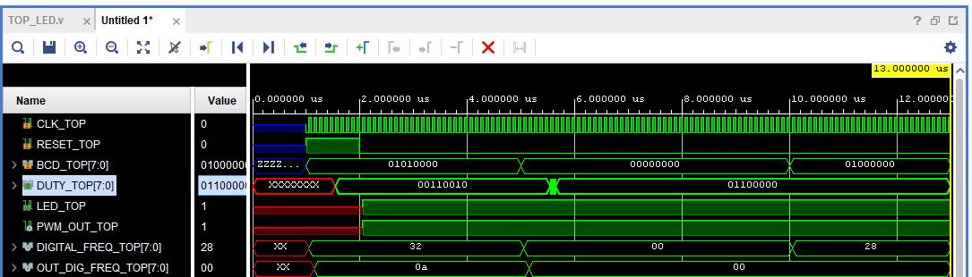

**Schematic View of Verification of TOP Module using VIO (Virtual Logic Analyzer) and ILA(Integrated Logic Analyzer) IPs of Vivado:**

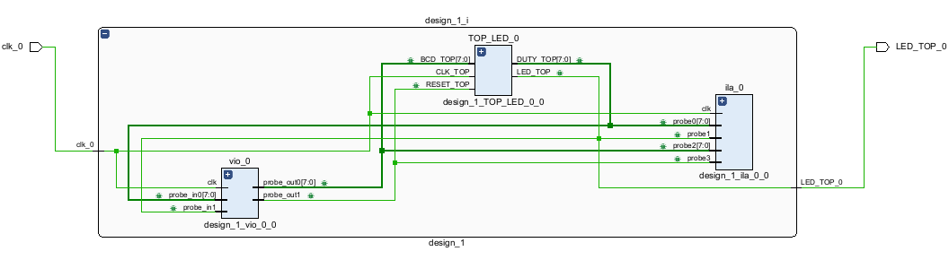

**Schematic View of TOP RTL Block:**

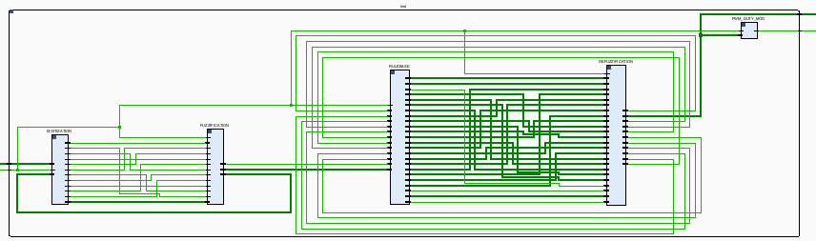

**Synthesized Schematic View after of Verification Setup:**

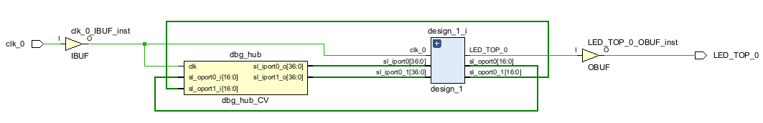

**Report Resourced Used after Synthesis:**

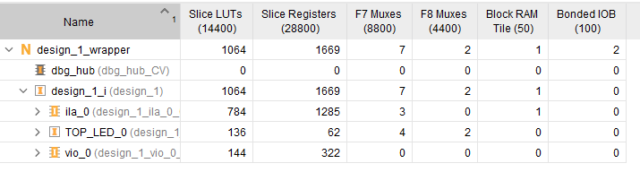

**Broad View of TOP RTL Block what I have designed is,**

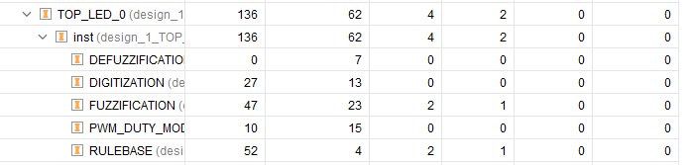

**Power Report After Synthesis:**

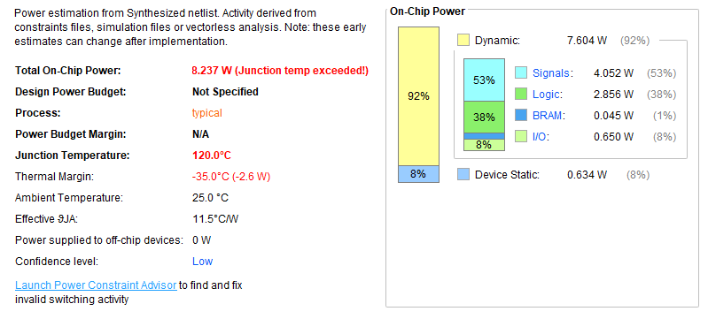

**Table of Contents**

**1. Slice Logic**

**1.1 Summary of Registers by Type**

**2. Memory**

**3. DSP**

**4. IO and GT Specific**

**5. Clocking**

**6. Specific Feature**

**7. Primitives**

**8. Black Boxes**

**9. Instantiated Netlists**

**1. Slice Logic by TOP Block:**

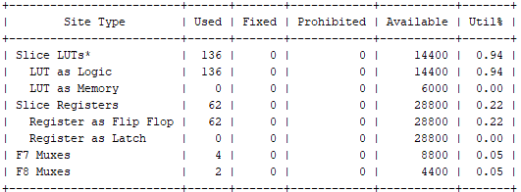

**By ILA:**

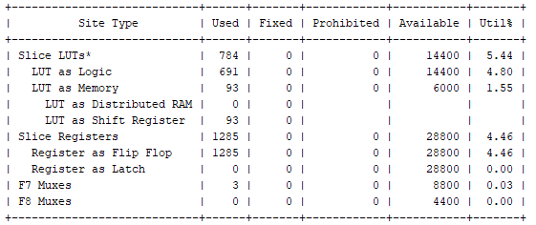

**By VIO:**

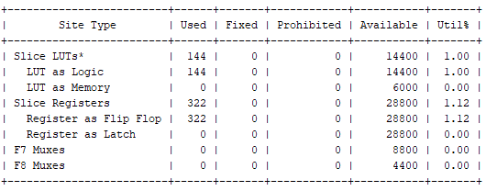

**7. Primitives by TOP block:**

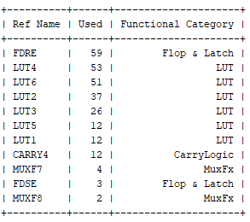

**By ILA:**

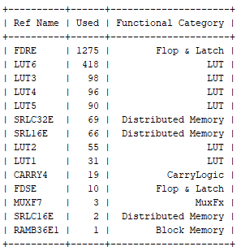

**By VIO:**

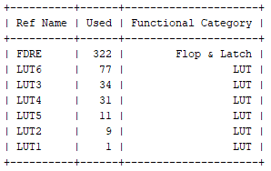

**Memory Used:**

**By TOP:**

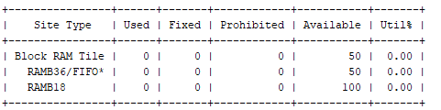

**By ILA:**

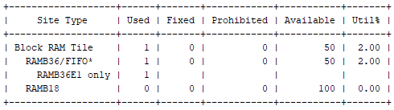

**By VIO:**

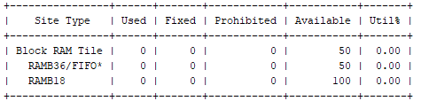

**Post Implementation Report:**

**Slack:**

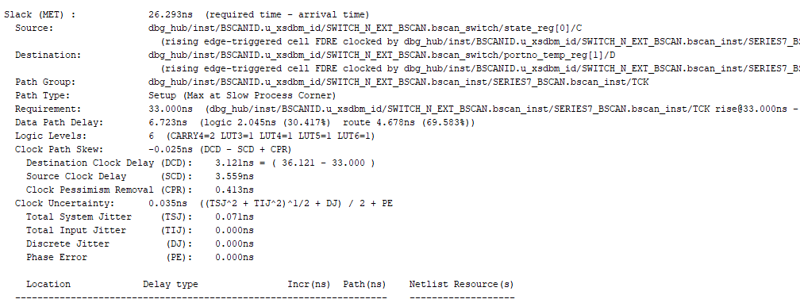

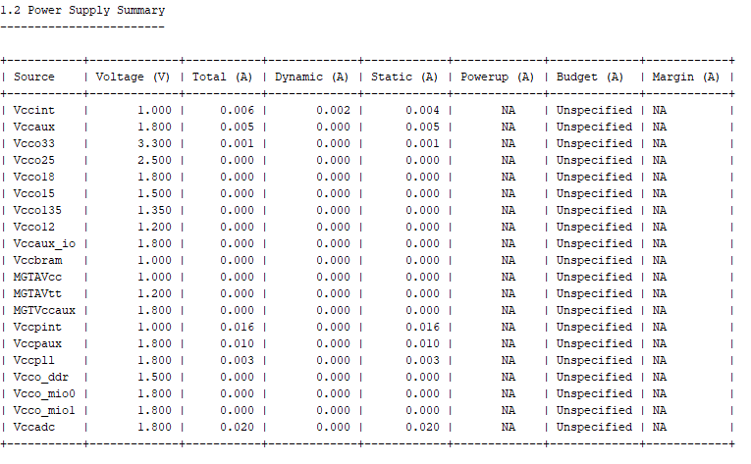

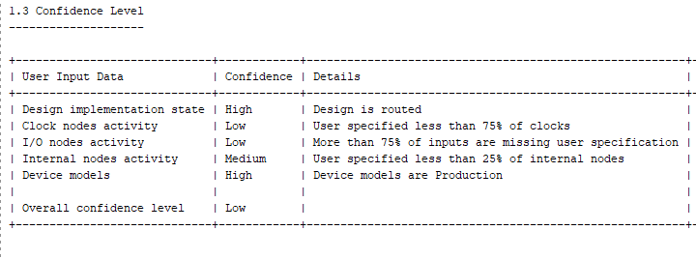

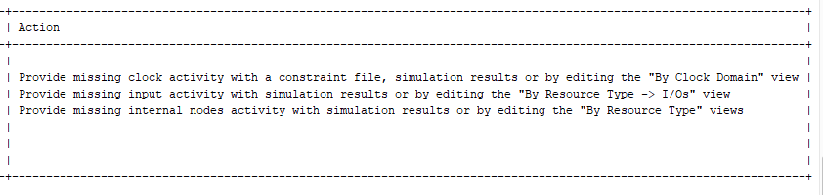

**Power Report:**

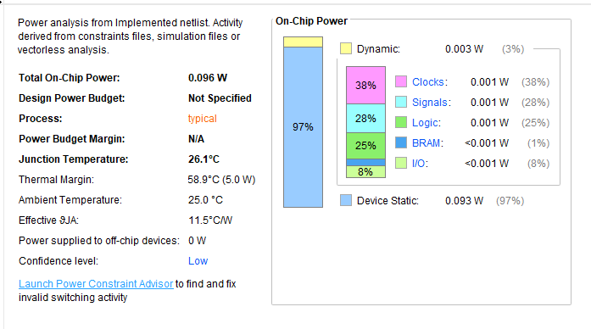

**Physical Constraints for I/O Pin:**

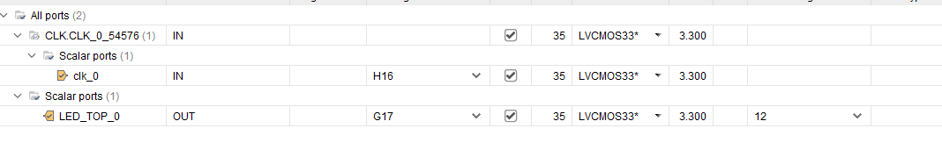

**Synthesized Schematic Diagram of Testing setup after Implementation:**

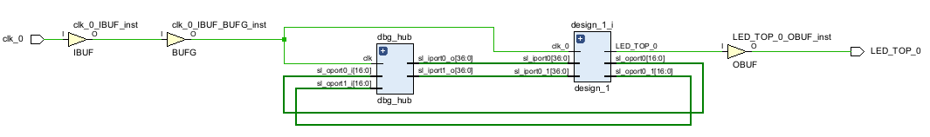

**Hardware Implementation and Verification using LED and VIO&ILA IPs(Hardware Manager Vivado) of FPGA/SoC (XC7Z007S-1CLG400C) of PWM Signal Generation:**

**VIO Inputs**

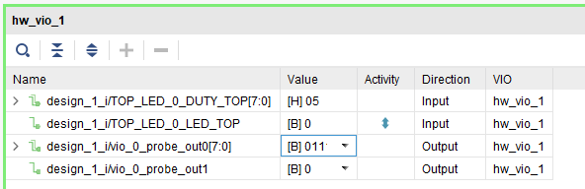

**ILA Outputs Waveform:**

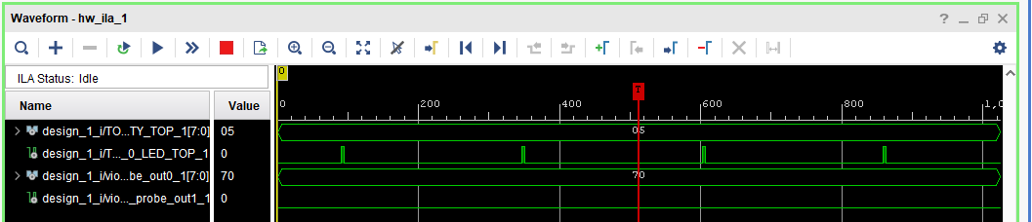

**2nd input**

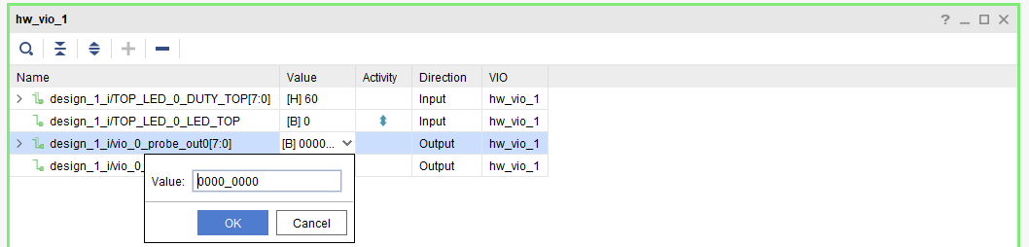

**2nd output:**

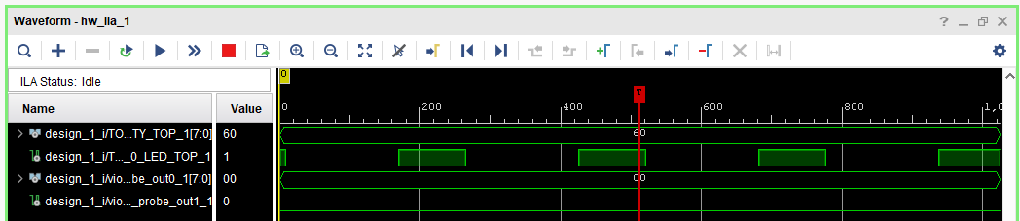

**3rd input:**

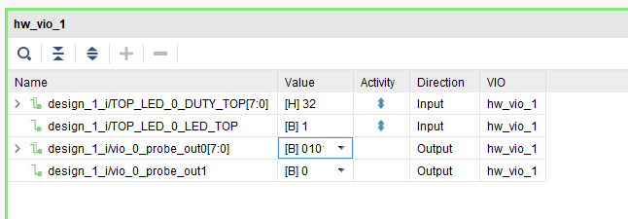

**3rd Output:**

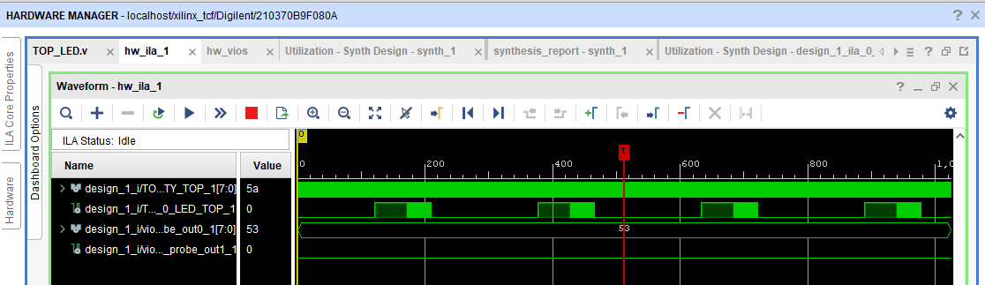

**Hardware Implementation Video:**

